37.47: a)
1 kg is equivalent to 2.2 lbs, so 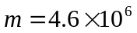 tons
b) The current mass of the sun is 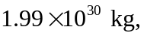 so it would take it to use up all its mass.

